SMART WATER MANAGEMENT USING IBM WATSON PLATFORM

**BY TEAMNO:18**

S.Dhushyanth Mohan Reddy(17481A04I2)

N.Anjaneyulu(17481A04N0)

G.Kalyan Babu(17481A04M0)

S.Gopi Kishore(17481A04H9)

**Table of Contents**

**1 INTRODUCTION**

1.1 Overview

1.2 Purpose

**2 LITERATURE SURVEY**

2.1 Existing problem

2.2 Proposed solution

**3 THEORITICAL ANALYSIS**

3.1 Block diagram

3.2 Hardware / Software designing

**4 EXPERIMENTAL INVESTIGATIONS**

**5 FLOWCHART**

**6 RESULT**

**7 ADVANTAGES & DISADVANTAGES**

**8 APPLICATIONS**

**9 CONCLUSION**

**10 FUTURE SCOPE**

**11 BIBILOGRAPHY**

**12 APPENDIX**

**1)INTRODUCTION:**

1.1 overview

Smart Water Management System We all know "Water is elixir of life." And immediately one question ticks my mind... How efficiently you are using it? Yes, the answer to this question is our project. The project Smart Water Supply Management, as the name says it all is about management of water supply throughout the scale, right from small societies, townships to entire urban infrastructure and also for irrigation water supply management. For Demonstration purpose we have restricted it to only 3 sensors. But sensor network can be flexibly expanded and shrunk according to the requirements of setup. It can also be used for remotely controlling the water flow, cutting the water supply, monitoring and analyzing the water usage across the nodes, with the help of android app and cloud connectivity. Further more statistical data gathered and can be used by govt. authorities for defining policies, strategies and billing calculations. So ultimately this will help to conserve and efficiently utilise the natural resource. using IoT takes in to account of water wastage right from our home to the large scale. It also can control the water usage in a precise way.

1.2 purpose

Presented here is a Water Management System using IoT. Water level and flow indication, water motor pump on/off are carried out by this project.

Real Time Monitoring:

water level measured by sensors is sent continuously to Nodered and forwarded to ibmcloud, it gives informationof water level through application developed through mit app inventer from which we can analyze our water usage.The solution also sends alerts via SMS text and email whenever water tank is100% filled.

Water management system could be benficialin :

1. Prevent water over flow from tanks
2. Water conservation
3. finding whether there is any leakage in the tank
4. analyse the water usage

The final say

All in all, the implementation of an IoT-basedSmart Water Management leads to the reduced utilization of water resources

**2)Literature Survey:**

2.1 Existing problems

a) water over flow from tanks when it is completely filled

b) Inappropriate water management can deplete water sources

c) deterioration in water quantity and quality due to over use

2.2 Proposed solution:

a) analysing water flow with sensors

b) alerts of water overflow is sent to authorized person

c) remote motor control to save water from over flow

**3)Theoretical Analysis:**

3.1 Block diagram

Create an IBM account

Create node red application

Create IBM Watson platform

Create MIT app inverter

Setup hardware and develop the code

Create code snippet for DHTLL sensor measure water level

Create code snippet for IR and LDR sensor

Create code snippet for motor and off

Create node red flow to receive and send data

Configure IOT platform and node red

Create HTTP request to communicate with mobile app

Building a mobile app

Design your UI to display sensor value to the motor

Alert when overflow the tank and send sms to motor

Configure the application to send the motor button status the cloud

3.2 Hardware / Software designing

Software design is nothing but creation of Create an IBM account then create note red then create IBM Watson platform and create MIT app inverter setup hardware and develop the code and code snippet for DHTLL sensor measure water level then open fast to SMS app and sign in create put the python code in that and put API key which was generated in IBM Watson cloud and run that code it will send SMS to that mobile by the MIT app we can control the motor we can ON or OFF the motor

**4) Experimental Investigation:**

The Internet of things(IoT) aims at connecting different objects, things using internet.The rapid development of the Internet of Things motivate use to apply for water management purpose such as to prevent the water wastage.In this project a system has been proposed to analyze the water levels and flow of water from the tank.The proposed solution senses the leakages present in tank, over flow of water during filling the water in tank.In this project we have designed and implemented an application through MIT app inventor and connected it to IBM cloud platform which gives the data to application from sensors. Finally this project is integrating the android mobile application which is used to facilitate user interaction and connect through IoT based system that is station/gateway and the internet.

**5)Flowchart:**

Establish connection between controller and network

Read input (water level)

If(water level =100)

YES

Buzzer on data is sent to the server

NO

**6)Result:**

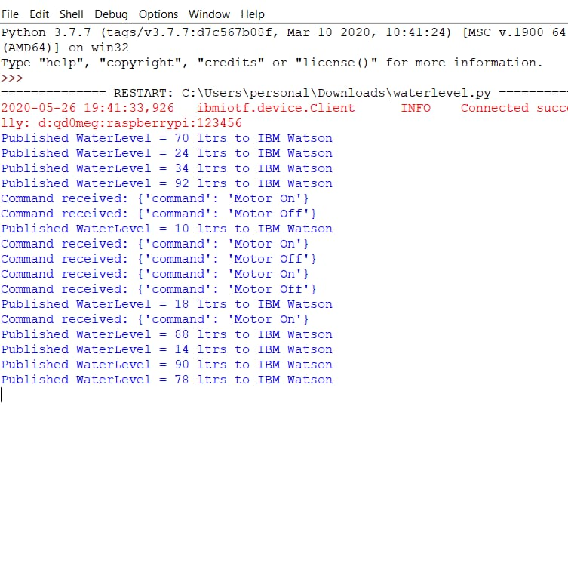

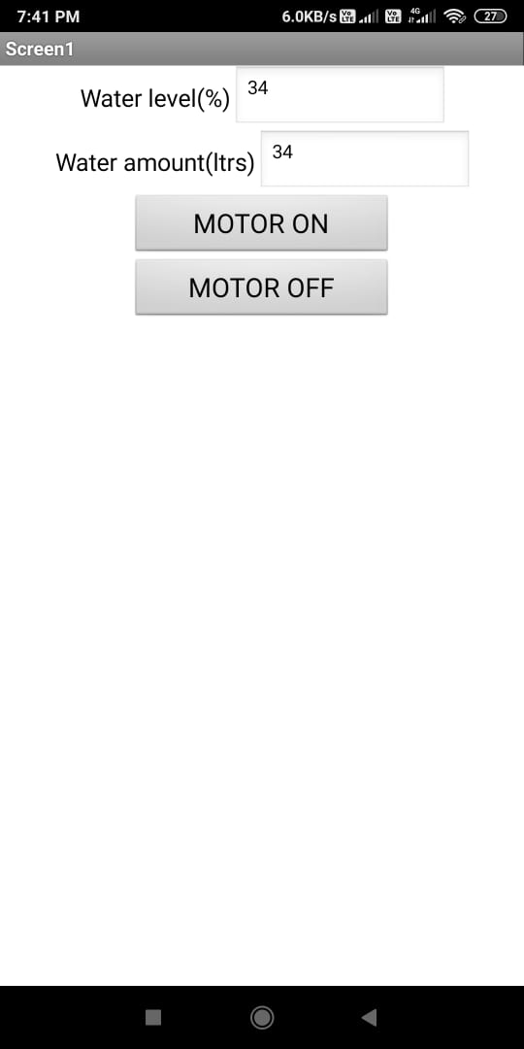

**7)Advantages and Disadvantages:**

Advantages:

1. water management system can analyze the water flow while controlling thewater level to help prevent the over flow and wastage of water.
2. Tanks can be fitted into everyone’s home, as they have many different shapes and sizes.

Disadvantages:

1. Water tanks have high chance of becoming dirty.
2. Water tanks can be very hard to clean.

**8)Applications:**

a) integrated water management in industries.

b) Weather-based irrigation controls: This type of control system saves water usage and cost especially during the hot summer months.

c)Reduced water and sewer costs: Low flow water conservation devices reduce water usage and costs as well as sewer costs.

**9) Conclusion:**

Our intention of this project work was to establish a flexible, economical, easily configurable and most importantly, a portable system which can solve our water wastage problem**.** Water is very important for sustenance of life. Water not only sustains life, but also determines the quality of life. Assessing water quantity is just as important as quality in water management.

**10) Future Scope:** Despite, of the fear of lack of fresh water the internet of things and IoT applications will help much more in the coming years as water management devices. Ultimately we can say the IoT future scope or the future of IoT is very bright. There will a lot of IoT devices which will be coming shortly with advancement in smart water management projects in urban and rural areas.

**11)Bibliography:**

Books:

1. Water Quality Monitoring for rural areas-A sensor cloud based economical project by Nikhil Kedia

2. Sensor-Network based Intelligent water quality monitoring and control by Li Zhenan, Wang Kai, Liu Bo

3. Boyle, T., Giurco, D., Mukheibir, P., Liu, A., Moy, C., White, S., and Stewart, R.:

‘Intelligent Metering for Urban Water: A Review’, Water, 5, (3), pp. 1052-1081 (2013)

Algorithms:

Thesmartbridgeteachable.com